Kiểm tra tình trạng docker:
Kiểm tra what
C:\Users\Admin>docker ps -a
CONTAINER ID IMAGE COMMAND CREATED STATUS PORTS NAMES
eb09d4ae5e2d ollama/ollama "/bin/ollama serve" 14 hours ago Up 14 hours 0.0.0.0:11434->11434/tcp ollama
07faeeee3df6 n8nio/n8n:1.20.0 "tini -- /docker-ent…" 16 hours ago Up 16 hours 0.0.0.0:5678->5678/tcp n8n_vinhtan
b8aba7d5e15b getmeili/meilisearch:v1.5 "tini -- meilisearch…" 12 days ago Up 5 days 0.0.0.0:7700->7700/tcp meilisearch_vintan
Kiểm tra where
C:\Users\Admin>docker volume ls
DRIVER VOLUME NAME
local n8n_data
local ollama_data
Kiểm tra how many
C:\Users\Admin>docker images
REPOSITORY TAG IMAGE ID CREATED SIZE
ollama/ollama latest 8a83449c249f 43 hours ago 6.04GB
getmeili/meilisearch v1.5 b93c6bfb0152 2 years ago 137MB
n8nio/n8n 1.20.0 a99fefcaf0b2 2 years ago 749MB

HIỆN TƯỢNG 2 MEILEI SEARCH
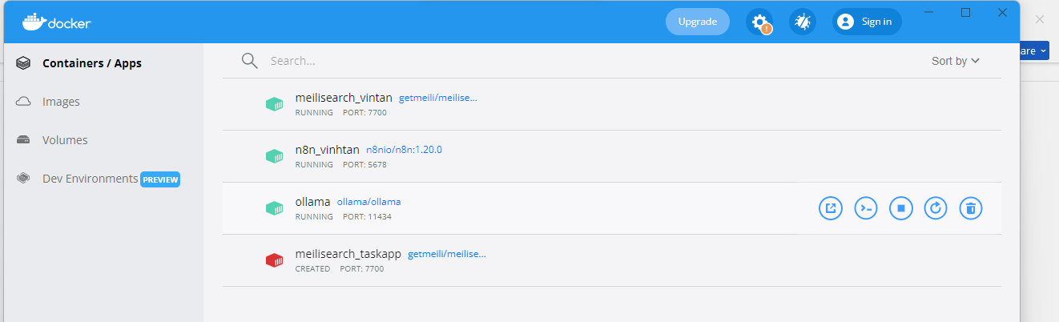XÓA 1 MEILEI SEARCH TÊN LÀ TASKAPP, GIỮ LẠI VINHTAN
docker rm -f meilisearch_vintan meilisearch_taskapp

